

Volume 2, Issue 4

April-May 2016

### CCAA Winner Speaks at CCHS

## On March 10, **Bob Alligood**, the CCAA (**Colquitt County Career Achievement Award**) winner spoke to CCHS students about his life long accomplishments that have lead him to being recognized by Colquitt County for his achievements.

## From 1952 to 1956, he served in the **U.S. Army**, and then, in 1960, he graduated with honors from the **University of Florida** with a degree in engineering. After graduating, he served as the executive director of the **Florida Engineering Society** in Orlando. He even served two terms with **Florida’s Legislature** for several Central Florida counties (1964 – 1967).

## For the next twenty years Alligood was an officer for the firm of **Reynolds Smith and Hills Inc.** and later became the president, CEO, and board member. After retiring from this firm, he founded **BA Consulting and Development, Inc.** and **HH&A Construction, Inc.** In Colquitt, he purchased and patented an ice vending machine and later named the company Ice House America. These machines provide ice for 37 states and countries such as Brazil.

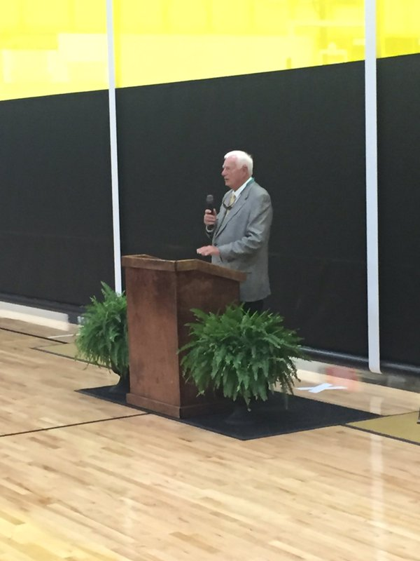

CCAA Winner, Bob Alligood, speaking to CCHS students in the gym.



CCAA Winner, Bob Alligood, sitting with CCHS students.

### 2016 CCHS STAR Student

## holly.jpg

## Left to right: STAR Student, Holly Cooper, and STAR Teacher, Liz Savage.

### **Holly Cooper** has been named the **2016 STAR Student** for CCHS, and she selected **Liz Savage** as her **STAR Teacher**.

Cooper’s superb performance on the SAT has earned her this position as the highest scoring student on the SAT from CCHS or the STAR Student.

Cooper participates in the 50th Regiment Band where she serves as the center snare. She is also the Company Commander of CCHS’s Marine Corps JROTC program. Cooper will be attending Mercer University next year where she will major in Music Performance.

IMportanT Dates

***April***

April 1

Gymnastics, Tift

April 4

Return from Spring Break

April 5 – 8

Prom ticket sale

April 5

Var. Tennis, Packer Park

April 7

Last Day for College Visitation

April 8

Girls/Boys Track, Westover Invitational

**April 9**

* **ACT (away)**
* **Prom: Bayou Ball**

April 11 – 16

End of Pathway Testing

April 12

* Var. Tennis, Region 1-AAAAAA Tourney
* Graduation Ticket Requests due for Seniors

April 14

Grades Due

April 16

Gymnastics, Area Meet

April 19

Report Cards

April 20 – 22

Girls/Boys Track, Region, Tift

April 30

Girls/Boys Track, Sectionals, Mill Creek

***May***

May 2

MCJROTC Awards Banquet

May 4

Josten’s Senior Supply Delivery

May 5 – 7

Girls Track, State, Albany

**May 7**

**SAT @ CCHS**

May 10

Var. Soccer Girls/Boys, Semi Finals, TBA

May 12 – 14

Boys Track, State, Jefferson

May 12 – 14

Var. Soccer Girls/Boys, Finals State, TBA

**May 17**

* **Honors Night, Underclassmen, 6PM**
* **Honors Night, Seniors, 7:30PM**

**May 18**

**Senior Graduation Picture, Graduation Tickets** passed out to Seniors

**May 18 – 19**

**Senior Finals**

**May 23 – 25**

**Underclassmen Finals**

**May 25**

**Early Release, Last Day of School**

May 26

Grades Due

**May 27**

**Graduation Practice**

**May 28**

**Graduation**

***June***

**June 4**

**SAT (Away)**

**June 11**

**ACT (Away)**

**June 13 – 17**

**Class of 2017 Senior Photos, 8AM – 5PM, CCHS Auxiliary Gym by Appointment**

**June 26 – 27**

**Senior Picture Retakes, 8AM – 5PM, CCHS Cafeteria Atrium**

## 2015 AAAAAA Champions

Have you failed a course? Are you missing units for **graduation**? Well, you still have the opportunity to recover those credits at Credit Recovery. This option to receive credit is FREE; just **pre-register**, show up, and do the work on the computer. Review the schedule below to make a plan (left). **Make up missing classes as soon as possible!** The deadline to make up credits during this school year is **May 20th**, but if you are unable to make up your credits by this date, the summer credit recover dates are listed below (right):

|  |  |  |  |
| --- | --- | --- | --- |
| **School Year Days** | Time (morning) | Time (Afternoon) | Location @ CCHS |
| Monday | **N/A** | 3:30 – 5:00 | Lab 112 |
| Tuesday | **N/A** | 3:30 – 5:00 | Lab 112 |
| Wednesday | **N/A** | 3:30 – 5:00 | Lab 112 |
| Thursday | **N/A** | 3:30 – 5:00 | Lab 112 |
| Saturday | 9:00 – 11:00 | **N/A** | Lab 112 |

### Credit Recovery

Varsity Soccer Girls/Boys

|  |  |  |  |
| --- | --- | --- | --- |
| **Competitor** | **Date** | **Time** | **Location** |
| Lowndes | April 12 | 6:00pm | Lowndes |
| Valdosta | April 14 | 6:00pm | Valdosta |
| Valdosta | April 15 | 6:00pm | Valdosta |
| **Tift** | **April 18** | **9:30am** | **Packer Park** |
| 1st Round Playoffs | April 26 – 29 | TBA | TBA |
| 2nd Round Playoffs | May 3 – 4 | TBA | TBA |
| Quarterfinals | May 6 – 7 | TBA | TBA |

|  |  |
| --- | --- |
| **Summer Days** | Time |
| June 6 - 10 | **8:00 am – 12:00 pm** |
| June 13 - 17 | **8:00 am – 12:00 pm** |

|  |  |  |  |
| --- | --- | --- | --- |
| **Girls/Boys** | **Competitor** | **Date** | **Location** |
| **G** | **TBA** | **April 2** | **Home** |
| B | Blue Devils Invitation | April 4 | Tifton |
| B | Hardaway Invitational | April 8 – 9 | Columbus |
| **G** | **Lowndes** | **April 14** | **Home** |
| B | Central HS Invitational | April 16 | Thomasville |
| **G/B** | **1 AAAAAA Tournament** | **April 18** | **Home** |
| G | Maple Ridge | April 23 | Columbus |
| **B** | **Sectionals** | **May 2** | **Home** |
| B | AAAAAA State | May 16 | Tifton |
| **G** | **State** | **May 23** | **Home** |

## Varsity Golf Girls/Boys C:\Users\21196\AppData\Local\Microsoft\Windows\Temporary Internet Files\Content.IE5\HCM1LS1T\183487,1277032955,4[1].jpg

Page 2

The Packer Press: News Print

In order for any student to obtain a Learners Permit or Driver’s license, they will need a Certificate of Attendance. For those that are trying to receive a Driver’s License, they will also need a copy of the Alcohol and Drug Prevention Certificate. Form requests for this information are at Counselors’ Corner, and it will take two days to complete these forms. Check back in at Counselors’ Corner to retrieve your completed forms.

***More Important Info.***

* Parent Teacher Conferences are held on Thursdays.
* Advisory Activities are on Tuesdays.
* Advisory Clubs are on Wednesdays.

### Driver’s License Information

Since Donna Mitchell is now the Director of Guidance, Justin Harrison is the new PAU-Z Counselor. If you have any concerns/questions, call your child’s counselor or visit the guidance department. If you do not know your child’s counselor, consult the following table:

|  |  |  |
| --- | --- | --- |
| Counselors | Counselors’ Corner Day | First Letter of Last Name |
| **Shatarra Brown** | Wednesday | A-HALL |
| **Monica Crenshaw** | Tuesday | HAM-PAT |
| **Justin Harrison** | Thursday | PAU-Z |

**Renee Tucker**, the Graduation Coach, is at Counselors’ Corner on Monday’s and **Maggie Brown** is there on Friday mornings. **Donna Mitchell** is available during lunch hours. **Deborah Ruddell** is at Counselors’ Corner in the mornings to handle early dismissal passes and excuses.

### Who is my counselor?

Here at CCHS students are provided with “Counselors’ Corner”. During breakfast and lunch hours, counselors are available to answer student questions. Along with answering questions, counselors also provide information such as documents, applications and events, etc.

The following information and handouts can be found at Counselors’ Corner:

* SAT/ACT Review Booklets, Dates, and DeadlineHandouts.
* Fee Waiver Application
* GaCollege411 Information
* Senior College Visitation Forms
* Promotion ofVoter Registration(April)
* Scholarship Info
* **ASVAB** information, dates, practice info.
* **Fee Waivers**- Pick up and turn in fee waivers at Counselors’ Corner.
* **Local Scholarship Application**- Available beginning October 1, pick up and return at Counselors’ Corner by January 15th.
* **SAT/ACT Registration Workshop**- Sign-up sheets with dates are located at Counselors’ Corner. A pass will be given to the extended period teacher to give to the students. The student will report to the computer lab with their credit card or fee waiver on the designateddate.
* **Transcript Requests**. **\*Important**- Students must send transcripts through their GA-411 account to all schools who accept electronic transcripts. Pick up a Transcript Request form at Counselors’ corner for out of state schools, private institutions & schools that do not accept electronic transcripts. Return the form to Counselor’s Corner. **Allow 3 - 5 days for processing**. Pick up transcript at Counselors’ Corner.
* **Prom-** Forms to take a date not from CCHS.

### What is The Counselors’ Corner?

Page 3

The Packer Press: News Print

### Selective Service

If you are a male, you are required to register for **Selective** **Service when you turn 18**. Selective Service began in 1940 when President Franklin Roosevelt signed the Selective Training and Service Act so that the U.S. Armed forces had more manpower then they would have with just an All-Volunteer military even in peacetime. This act ended in 1975, but President Jimmy Carter brought it back in 1980 because of the Soviet invasion of Afghanistan, and Selective Service has continued today.

If a man hasn’t registered by the age of 26 but has been in the U.S. before this age, he can be prosecuted and fined up to $250,000 with five years in prison, and he is no longer eligible for student financial aid, U.S. Citizenship, Federal Job Training, or Federal Jobs. Georgia penalties also include not meeting student financial aid requirements, but **you must also register for Selective Services in order to have state employment and a state driver’s license**.

Luckily, registering isn’t difficult. You can register at **http://www.sss.gov/**, you can pick up the **Registration Forms at the U.S. Post Office**, or you can check the **“Register Me” Box #22 on the application for the Federal Student Financial Aid (FAFSA form)**. Men are obligated to register at 18 because of the Military Selective Service Act, so don’t wait until the last minute, go ahead and register today.

Important SAT/ACT Information

It’s that time again! The SAT and ACT are extremely important when it comes to applying to college, especially for seniors. You don’t want to wait until the last minute to take a test that can make or break your chances of getting into college! Leave yourself enough room to take another SAT or ACT just in case you don’t get the score you want on your first attempt. Juniors, go ahead and take them now rather than waiting until your senior year. It’ll give you more practice. Counselors’ Corner also has information with dates of the SAT and ACT tests and costs.

**SAT** Dates @ CCHS

|  |  |  |
| --- | --- | --- |
| Test Date | Deadline to Register | Late Registration (Late Fee) |
| May 7, 2016 | April 8 | April 9 – 26 |
| June 4, 2016 | May 5 | May 6 – 25 |
| October 1, 2016 | September 2 | September 3 – 16 |

**ACT** Test Dates @ CCHS

|  |  |  |
| --- | --- | --- |
| Test Date | Deadline to Register | Late Registration (Late Fee) |
| April 9, 2016 | March 4, 2016 | March 5 – 18 |
| June 11, 2016 | May 6, 2016 | May 7 – 20 |
| September 10, 2016 | August 5, 2016 | August 6 – 19 |

Phone 229-890-6141

E-mail:

[thepackerpress@gmail.com](mailto:thepackerpress@gmail.com)

Follow us on Twitter

@ThePackerPress

*Left to right: Danielle Collum, Lance Shealey, Ian Brinson, Sunny Cannon, and Mary Grace Edgar.*

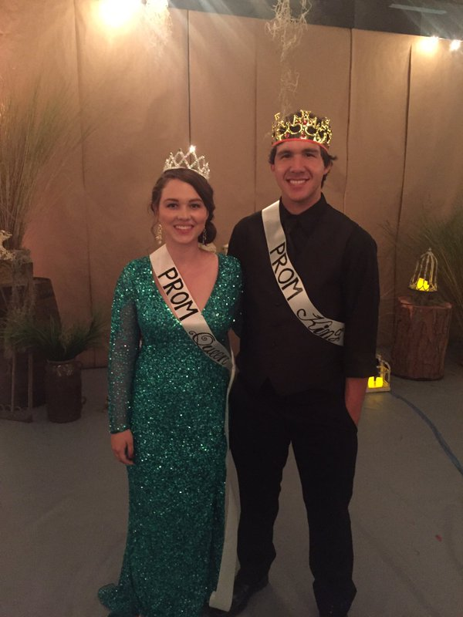

Congrats, Prom King, Queen, Prince, and Princesses!

On April 9, 2016, at the Bayou Ball, Lance Shealey was named Prom King, Danielle Collum as Prom Queen, Ian Brinson as Prom Prince, and Sunny Cannon and Mary Grace Edgar tied for Prom Princess.



The Packer Press

Staff Members:

Cassidy Weaver

Gabriella Lirio

Allison Logan

Bre Copeland

Daijranae McCloud

Noemi Charles

Dylan Wages

Ty Breland

Delilah Wood,

Webmistress & Journalism Intern

Susan Passmore,

Faculty Adviser

The Packer Press

Colquitt County

High School

105 Darbyshire Road

Norman Park, GA 31771

The Packer Press: News Print

Page 4